Nexus 7 1024x768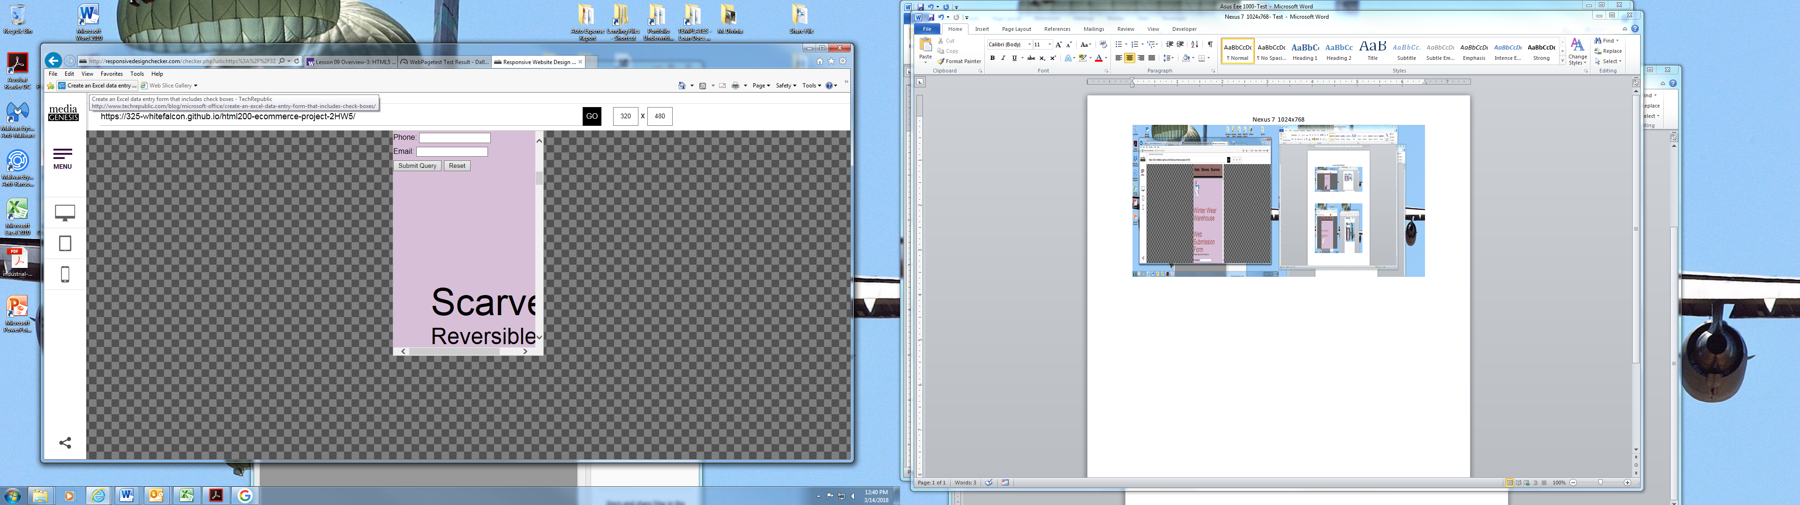

Apple Iphone 3/4/4s 